Module 6: Jenkins Assignment – 3
Tasks To Be Performed:
1. Create a pipeline in Jenkins
2. Once push is made to “develop” a branch in Git, trigger job “test”. This will
copy Git files to test node
3. If test job is successful, then prod job should be triggered
4. Prod jobs should copy files to prod node

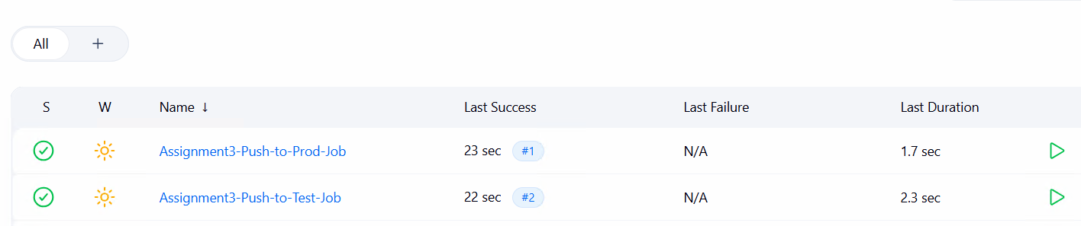
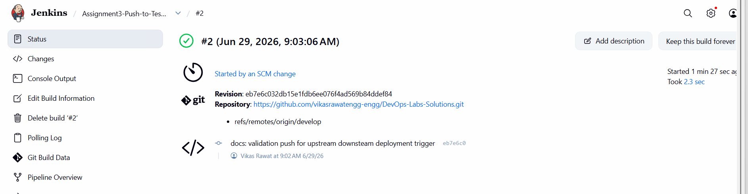
pipeline {
// Restricts execution safely to your dedicated test EC2 agent instance
agent { label 'test-environment' }

stages {
stage('Clean Target Workspace') {
steps {
deleteDir()
echo "Test node environment folder scrubbed cleanly."
}
}

stage('Deploy Files to Test Node') {
steps {
dir('test-server-deployment') {
git branch: 'develop',
credentialsId: 'github-token-id',
url: 'https://github.com/vikasrawatengg-engg/DevOps-Labs-Solutions.git'
}
echo "Success: Code deployed cleanly onto the testing node environment host."
}
}

stage('Trigger Production Gate') {
steps {
echo "Test phase passed successfully! Initializing production deployment link..."
// Native pipeline command to chain and launch the production deployment job
build job: 'Push-to-Prod-Job', wait: false
}
}
}
}

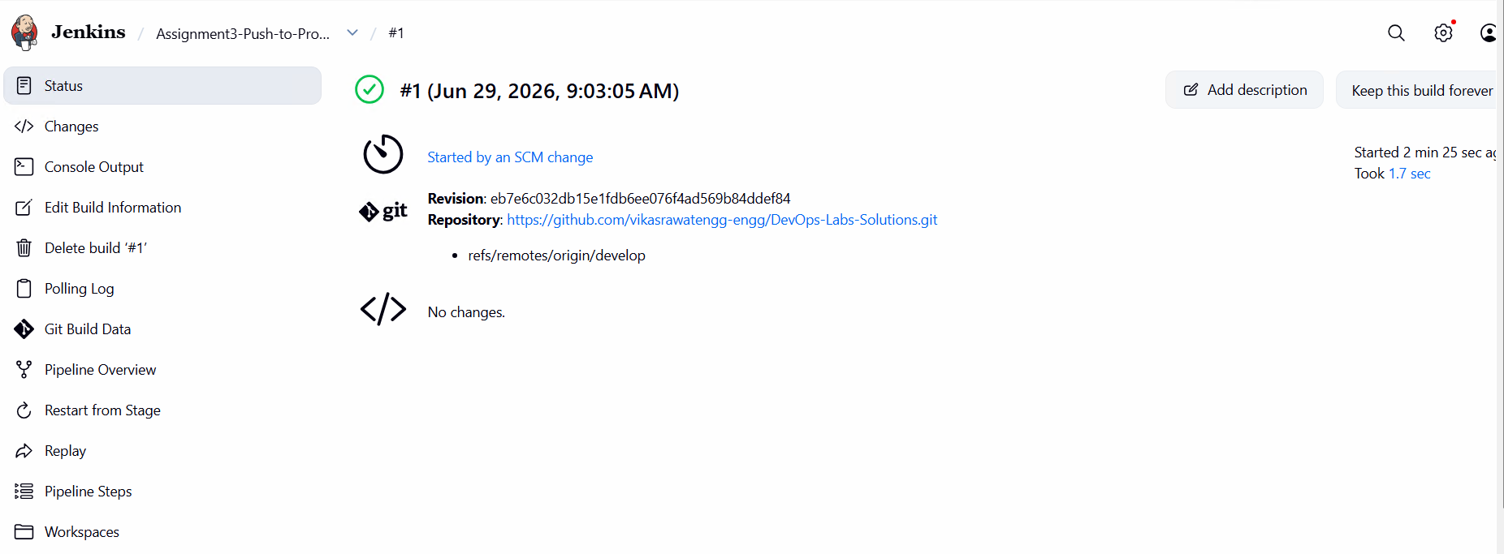
pipeline {
// Forces this pipeline to deploy locally on your main production master host layout
agent { label 'built-in' }

stages {
stage('Clean Production Workspace') {
steps {
deleteDir()
echo "Production core workspace safely cleared."
}
}

stage('Deploy Files to Production Node') {
steps {
dir('prod-server-deployment') {
git branch: 'develop',
credentialsId: 'github-token-id',
url: 'https://github.com/vikasrawatengg-engg/DevOps-Labs-Solutions.git'
}
echo "Success: Production deployment complete. Files migrated to prod server."
}
}
}
}

